Egyptian E-Learning University

Faculty of Computers & Information Technology

  - MidWise
Prepared By
Mina Ayman Milad Awad | 2202040
Kerolos Maged William | 2202089
Kerolos Saadalla Younan | 2202029
Kerolos Yaser Adly | 2202139
Tadros Wagdy Nasif | 2202137
Youssef Gergis Shafiq | 2202121
Mina Amjad Rafla | 2202087
Peirre Nabil Isak | 2202021
Ziad Tamer Mohsen | 2202047

  - Supervised by
Dr. Samar
  - Assistant
Eng. Basma Bassem

[Fayoum]-2025

Abstract
The problem: Drug interactions represent a serious health risk, especially for elderly patients who often take multiple medications daily without adequate time intervals between doses. These interactions may reduce drug effectiveness or cause harmful side effects, leading to complications that could have been avoided with proper guidance and monitoring. The lack of awareness, forgetfulness, and difficulty in understanding medical instructions increase this problem among older adults.
The motivation behind the MidWise project is to provide a simple, safe, and intelligent solution that helps users manage their medications and avoid dangerous drug interactions. MidWise allows users to enter the names of their medications, then analyses the active ingredients using a medical database to detect potential interactions. If an interaction exists, the system provides clear warnings and recommends appropriate time intervals between medications. Even when no interaction is detected, preventive advice is still provided.
The tools: system also includes a chatbot that explains drug interactions in a simple, non-technical manner suitable for elderly users, a reminder system to ensure medication adherence, a caregiver monitoring feature for family members, and an emergency alert button for urgent situations. The project is implemented using a database-driven system, interaction analysis logic, and user-friendly mobile application tools to enhance medication safety and quality of life.

Acknowledgments
The success of any project depends largely on the encouragement and guidelines of many others. We take this opportunity to express our gratitude to the people who have been instrumental in the successful completion of this project.

The special thanks go to our helpful supervisor Dr. Samar Hesham and our teaching assistant Eng. Basma Bassem.

The supervision, guidance, and support they gave truly helped in the progression of our graduation project. We also take this opportunity to express our gratitude to the board of the Faculty of Computers and Information Technology, Egyptian E-Learning University (EELU) for their support and efforts in providing us with all useful resources.

We express a special thanks to the faculty staff for the valuable information provided by them in their respective fields.

Lastly, we thank God, our parents, and all the people who helped, supported, and encouraged us to successfully finish the graduation project.

Contents
Abstract 2
Acknowledgments 3
1.Introduction 6
2.Literature Review / Related Work 7
3.Proposed system 8
3.1 Approach Used to Solve the Problem……………………………..………………8
3.2 System Architecture……………………………………………………………10
4.Implementation 17
4.1 Technologies, Tools, and Programming Languages Used……………………17
4.2 Key Components / Modules of the System..…………………………………18
4.3 Challenges Faced and How They Were Resolved……………………………..18
5.Testing & Evaluation 20
5.1 Testing Strategies………………………………………………………………..21
5.1.1 Unit Testing
5.1.2 Integration Testing
5.1.3 User Testing
5.2 Performance Metrics…………………………………………………………….23
5.2.1 Accuracy
5.2.2 Response Time
5.2.3 Chatbot Effectiveness
5.2.4 Reliability
5.2.5 Scalability
5.3 Comparison with Existing Solutions………………………………………………24
6.Results & Discussion 26
6.1 Introduction……………………………………………………………………….27
6.2 Summary of Findings……………………………………………………………..27
6.3 Interpretation of Results…………………………………………………………28
6.4 Limitations of the Proposed Solution……………………………………………..28
7.Conclusion & Future Work 30
7.1 Summary of Contributions………………………………………………………..31
7.2 Possible Improvements or Extensions for Future Work…………………………..31
8.References 33
9.Appendices (Optional) 35

Chapter 1: Introduction

In today’s fast-paced world, managing medications has become a significant challenge, especially for elderly patients who often take multiple drugs daily. The risks of drug interactions, missed doses, or improper scheduling can lead to serious health complications, reduced effectiveness of medications.
The MidWise project aims to address these challenges by providing an intelligent, user-friendly system that helps patients manage their medications safely and efficiently. MidWise allows users to enter their medications and automatically checks for potential drug interactions, offering clear guidance and recommendations. Even when no dangerous interactions are found, the system provides preventive advice to optimize medication use.
In addition to drug interaction analysis, MidWise includes a chatbot that explains medical information in simple terms suitable for elderly users, a reminder system to ensure adherence to medication schedules, and a caregiver monitoring feature that allows family members to follow the patient’s health remotely. The system also features an emergency alert function, giving patients a reliable way to notify caregivers in urgent situations.
By combining medication management, safety guidance, and real-time monitoring, MidWise aims to improve the quality of life for elderly patients, enhance medication safety, and provide peace of mind for both patients and their caregiv

Chapter 2: Literature Review / Related Work
Existing Implementations: Several applications exist in the market, such as Medisafe (for reminders and adherence tracking) and WebMD (for drug interaction checking). These apps allow users to manage medications, set schedules, and access basic medical information.
Main Differences:
Elderly-Focused Design: Unlike standard apps with complex interfaces, Midwise prioritizes a simple, user-friendly design specifically tailored for elderly users (NFR1).
Proactive Safety Advice: Midwise goes beyond simple warnings by providing recommended time intervals between interacting medications to help users schedule doses safely.
Simplified Chatbot: It offers an integrated AI chatbot that delivers non-technical, simple explanations, making medical advice accessible to everyone.
Integrated Emergency Loop: Midwise uniquely combines a dedicated Emergency SOS button with real-time Caregiver Monitoring, ensuring instant alerts are sent to family members during a crisis.

Chapter 3: Proposed system
3.1 Approach Used to Solve the Problem:
The MidWise project addresses the problem of drug interactions and elderly medication management using a user-centric approach and combining multiple software techniques:
- Medical Data Collection:
  - A database of medications and their active ingredients.
  - Reliable sources for drug interaction data.
- Drug Interaction Analysis:
  - Each medication has a specific active ingredient.
  - The system checks all entered medications for possible interactions.
  - If an interaction exists: a warning is displayed with advice (e.g., “take medications at different times” or “consult your doctor”).
  - If no interaction exists: a safe message is displayed with optional advice.
- Ease of Use:
  - A simple chatbot explains interactions in plain language.
  - Reminders notify the user when to take their medications.

  - An emergency alert button notifies caregivers or family in urgent situations.
- Remote Monitoring:
  - Family members or caregivers can access the system to monitor the user’s daily medication intake.

The solution relies on an accurate database + automated interaction checking + easy-to-use interface + reminders and monitoring system.

3.2 System Architecture
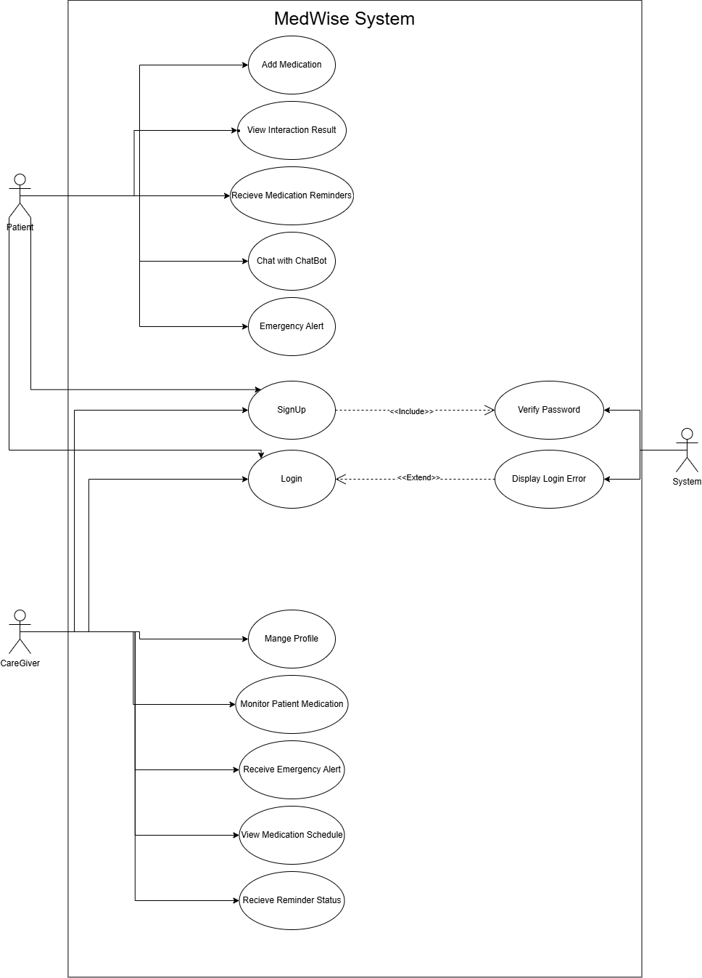
Use Case Flow:

ERD Diagram:
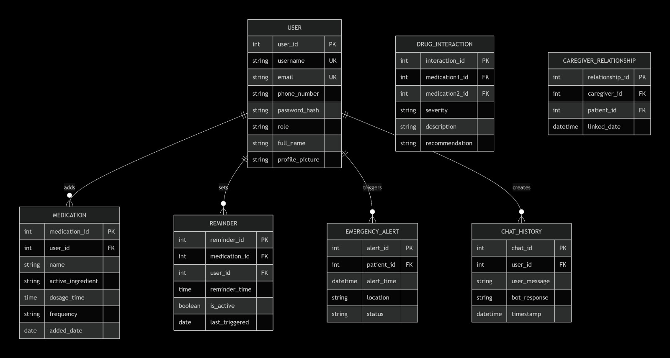

Sequence Diagram – Medication Entry:
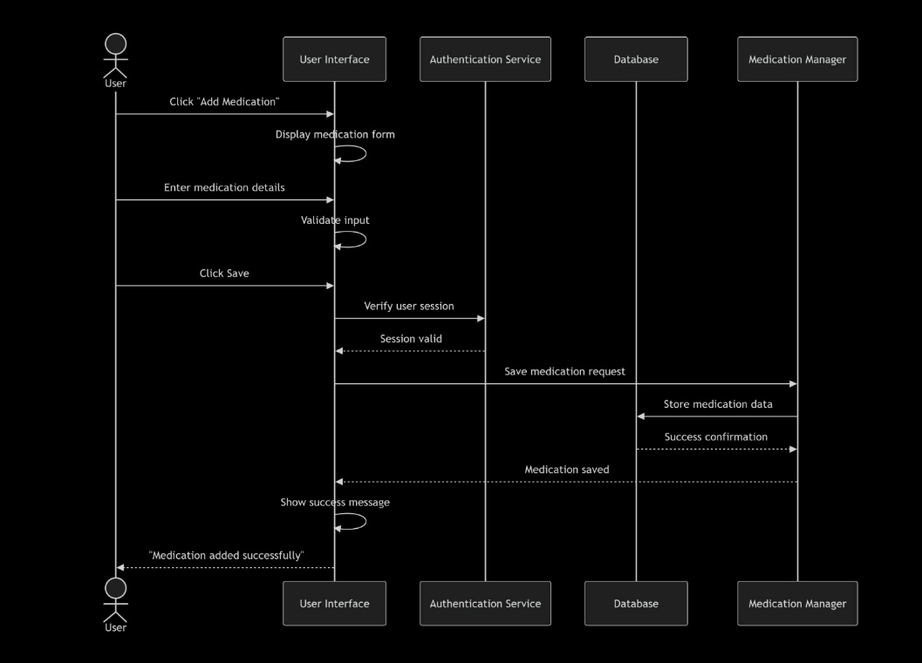

Sequence Diagram – Emergency Alert:

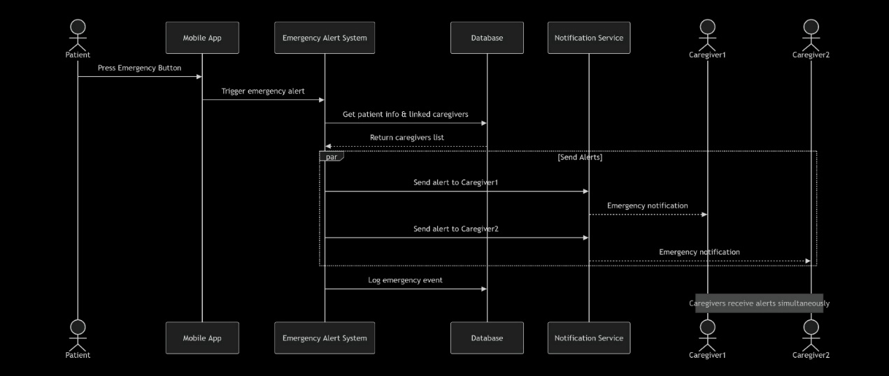

Schema Diagram:
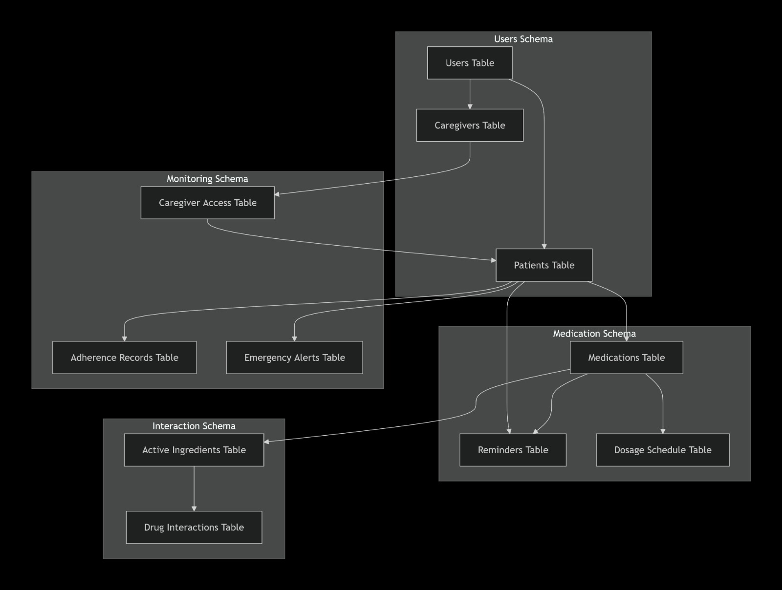

Activity Diagram:

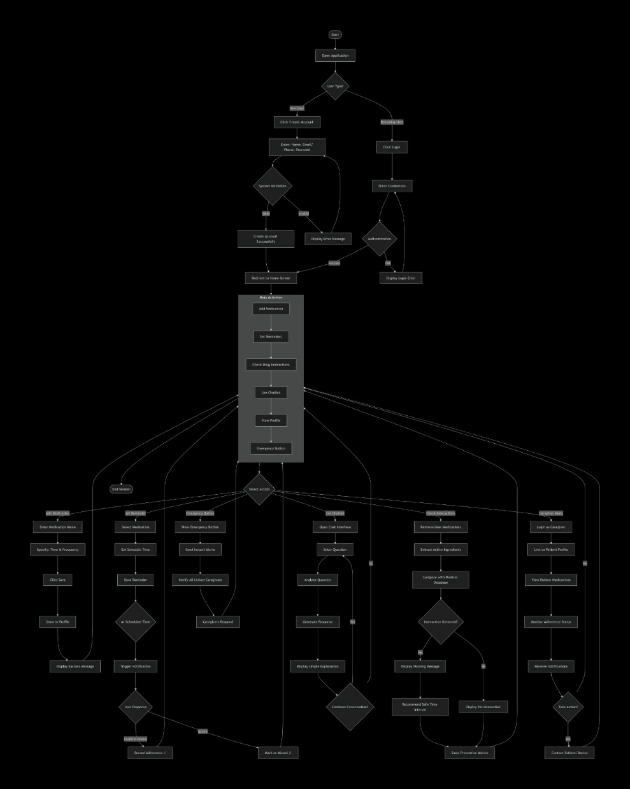
Class Diagram:

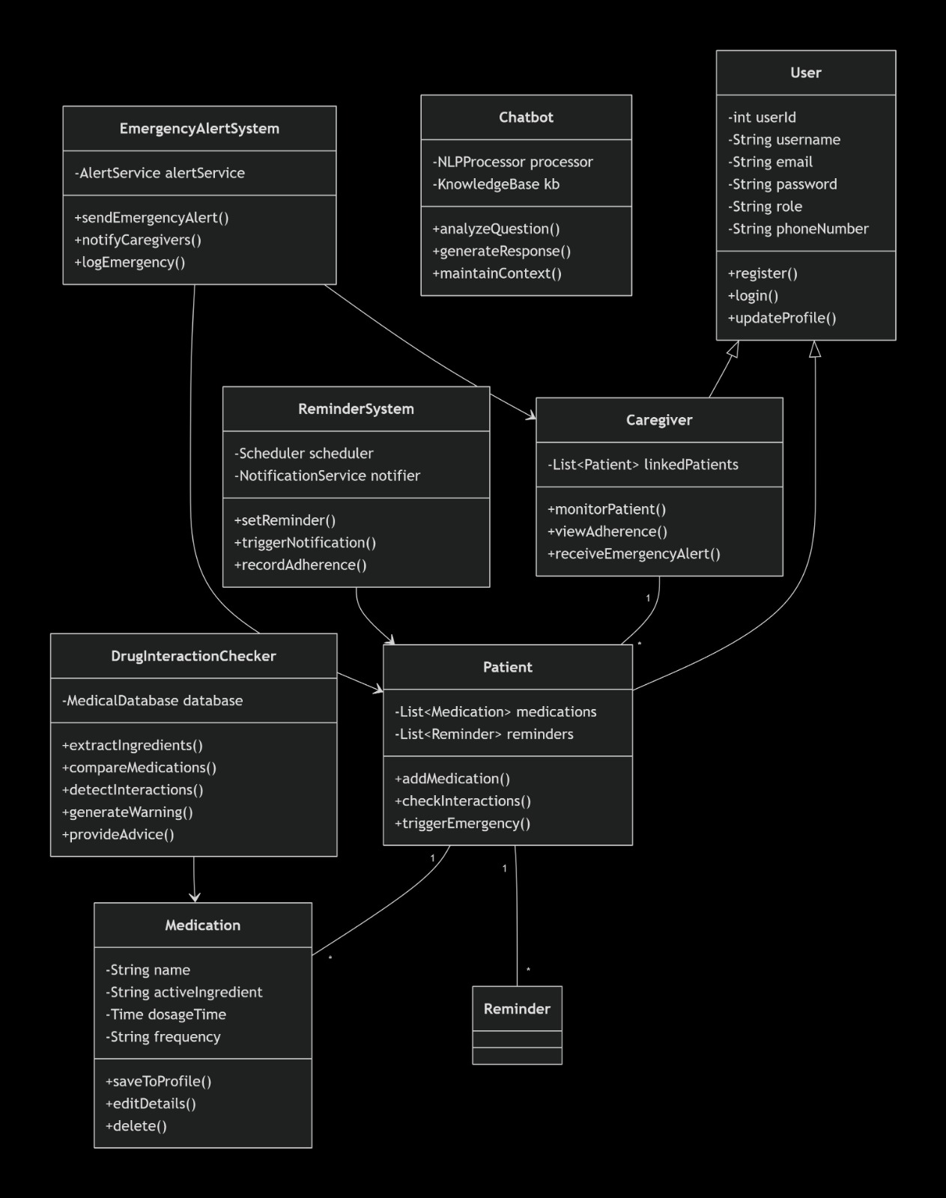

Stakeholders:
- Primary Stakeholders: Elderly users who take multiple medications and need guidance to prevent drug interactions.
- Secondary Stakeholders: Family members, caregivers, and healthcare providers who monitor the user’s medication intake and respond to alerts.

Functional Requirements:
- The system shall enable users to add, update, and manage all medications they are taking.
- The system must identify active ingredients and automatically detect potential drug–drug interactions.
- The system shall provide clear warnings and simple medical advice when interactions occur, and safe guidance when no interaction is detected.
- The system should include an intelligent chatbot to explain drug interactions and medication usage in a simple, elderly-friendly manner.
- The system should allow users to set, edit, and receive medication reminders and notifications.
- The system shall support caregiver access, allowing family members to remotely monitor medication schedules and alerts.
- The system must provide an emergency alert feature that instantly notifies caregivers in urgent situations.

Non-functional Requirements:
- The system should be easy to use, intuitive, and accessible for elderly users.
- The system should support bilingual interaction in Arabic and English.
- The system shall deliver real-time responses for interaction checks, reminders, and emergency alerts.
- The system shall ensure data security, privacy, and controlled access to sensitive user information.
- The system must be reliable and available at all times, especially for reminders and emergency notifications.
- The system should be scalable to support future expansion in users, medications, and medical data.

Chapter 4

Implementation

4.1 Technologies, Tools, and Programming Languages Used
The MidWise system was developed using a combination of modern technologies and tools to ensure reliability, usability, and scalability.
Programming Languages
- Python: Used for implementing the backend logic, drug interaction analysis, chatbot integration, and data processing.
- JavaScript: Used for frontend interactivity and dynamic user interfaces.
- HTML5 & CSS3: Used for designing and structuring the web application's user interface.
Frameworks and Libraries
- Flask/Django (depending on what you're using): Used for backend development and API management.
- Bootstrap: Used to create a responsive and user-friendly interface suitable for elderly users.
- Pandas: Used for handling and analyzing drug datasets.
- OpenAI API / NLP Libraries: Used to implement the chatbot functionality and provide simplified explanations of drug interactions.
Database
- MySQL (or the database you are using): Used to store user accounts, medication schedules, caregiver information, and drug interaction data.
Development Tools
- Visual Studio Code (VS Code): Main development environment.
- Git & GitHub: Used for version control and collaboration.
- Postman: Used for testing APIs and backend services.

4.2 Key Components / Modules of the System
The MidWise system consists of several integrated modules that work together to provide a complete healthcare assistance solution.
1. User Management Module
This module handles user registration, login, profile management, and authentication. It ensures that each user can securely access their personal medication records.
2. Drug Interaction Detection Module
This is the core component of the system. It analyzes the medications entered by the user and checks for potential interactions between their active ingredients using the drug database.
3. AI Chatbot Module
The chatbot assists users by explaining drug interactions and medication-related information in simple and understandable language. This feature is particularly useful for elderly users who may find medical terminology difficult to understand.
4. Medication Reminder Module
This module allows users to schedule medication times and receive reminders. It helps improve medication adherence and reduces the likelihood of missed doses.
5. Caregiver Monitoring Module
This component enables family members or caregivers to monitor the user's medication schedule and receive updates regarding medication adherence.
6. Emergency Alert Module
The emergency alert feature allows users to send an immediate notification to registered caregivers or family members in emergency situations by pressing a dedicated alert button.
7. Database Management Module
Responsible for storing and retrieving user information, medication schedules, interaction records, caregiver details, and system logs.

4.3 Challenges Faced and How They Were Resolved
During the development of MidWise, several challenges were encountered. Appropriate solutions were implemented to overcome these difficulties.
Challenge 1: Accurate Drug Interaction Detection
Problem: Identifying reliable drug interaction information and ensuring accurate results.
Solution: A structured drug database containing active ingredients and interaction records was used. Validation checks were also implemented to improve the accuracy of the interaction analysis process.
Challenge 2: Simplifying Medical Information
Problem: Drug interaction descriptions are often complex and difficult for elderly users to understand.
Solution: An AI-powered chatbot was integrated to provide simplified explanations using clear and user-friendly language.
Challenge 3: Designing for Elderly Users
Problem: Elderly users may face difficulties using complicated interfaces.
Solution: A simple and intuitive user interface was designed with large buttons, clear navigation, and readable fonts to improve accessibility.
Challenge 4: Medication Adherence
Problem: Users may forget to take medications on time.
Solution: A reminder system was implemented to send notifications and alerts at scheduled medication times.
Challenge 5: Emergency Communication
Problem: In emergency situations, users may not be able to quickly contact family members.
Solution: An emergency alert feature was developed to instantly notify registered caregivers and family members when assistance is needed.
Challenge 6: Remote Monitoring
Problem: Family members cannot continuously monitor elderly patients in person.
Solution: A caregiver monitoring module was introduced, allowing authorized family members to track medication schedules and receive important updates remotely.

Chapter 5

Testing & Evaluation

5.1 Testing Strategies
To ensure the reliability, accuracy, and usability of the MidWise system, several testing strategies were conducted throughout the development process.
5.1.1 Unit Testing
Unit testing was performed on individual modules to verify that each component functioned correctly and independently.
The tested modules included:
- User registration and login.
- Drug interaction detection.
- Medication reminder scheduling.
- Emergency alert activation.
- Caregiver management functions.
- AI chatbot responses.
The purpose of unit testing was to identify and fix errors at an early stage before integrating the modules into the complete system.
5.1.2 Integration Testing
After verifying each module individually, integration testing was conducted to ensure proper communication between system components.
Examples of integration tests include:
- Verifying that medication data entered by the user is correctly transferred to the drug interaction detection module.
- Ensuring reminder notifications are generated using stored medication schedules.
- Confirming that emergency alerts are successfully sent to registered caregivers.
- Testing the interaction between the chatbot and the drug information database.
Integration testing helped detect communication and data flow issues between modules.
5.1.3 User Testing
User testing was carried out to evaluate the usability and effectiveness of the system from an end-user perspective.
Participants were asked to:
- Register and create accounts.
- Enter medications.
- Check for drug interactions.
- Set medication reminders.
- Use the chatbot to obtain information.
- Trigger emergency alerts.
Feedback was collected regarding:
- Ease of navigation.
- Interface clarity.
- Readability of information.
- Overall user satisfaction.
The results indicated that the system was easy to use and particularly suitable for elderly users due to its simple interface and clear instructions.

5.2 Performance Metrics
Several performance metrics were used to evaluate the effectiveness of the MidWise system.
5.2.1 Accuracy
Accuracy measures the system's ability to correctly identify drug interactions based on the available database.
The evaluation showed that the system successfully detected known interactions and provided appropriate warnings, making it a reliable decision-support tool for medication management.
5.2.2 Response Time
Response time refers to the time required for the system to analyze medications and display results.
The drug interaction checking process typically completes within a few seconds, ensuring a smooth user experience.
5.2.3 Chatbot Effectiveness
The chatbot was evaluated based on its ability to provide understandable explanations for drug interactions.
Results showed that users could easily understand the chatbot responses, reducing confusion caused by complex medical terminology.
5.2.4 Reliability
The system was tested under different usage scenarios to ensure stable operation.
The application consistently performed its intended functions without significant failures or interruptions.

5.2.5 Scalability
The system architecture was designed to support future expansion, including:
- Additional drug databases.
- More users and caregivers.
- Enhanced AI capabilities.
- Mobile application integration.
This scalability ensures that MidWise can accommodate increasing demand and future improvements.

5.3 Comparison with Existing Solutions
Several existing healthcare applications provide medication reminders or drug information. However, MidWise combines multiple essential healthcare services within a single platform.
Feature | MidWise | Traditional Reminder Apps | Drug Information Apps
Medication Reminders | ✓ | ✓ | ✗
Drug Interaction Detection | ✓ | ✗ | ✓
AI Chatbot Explanation | ✓ | ✗ | ✗
Caregiver Monitoring | ✓ | ✗ | ✗
Emergency Alert System | ✓ | ✗ | ✗
Elderly-Friendly Design | ✓ | Limited | Limited

Advantages of MidWise
- Combines medication management and drug interaction analysis in one platform.
- Provides easy-to-understand explanations through an AI chatbot.
- Supports caregiver monitoring for remote assistance.
- Includes an emergency alert feature for critical situations.
- Designed specifically with elderly users in mind.

Summary
Compared to existing solutions, MidWise offers a more comprehensive healthcare support system by integrating drug interaction detection, medication reminders, caregiver monitoring, AI assistance, and emergency response features into a single user-friendly application. This combination of features makes the system more effective for supporting elderly individuals and patients who manage multiple medications daily.

Chapter 6

Results & Discussion

6.1 Introduction
This chapter presents the results obtained from the development and testing of the MidWise system. The purpose of this evaluation is to determine whether the proposed solution successfully addresses the identified problem of drug interaction awareness, medication adherence, and elderly healthcare support.
The system was tested using different scenarios involving medication management, drug interaction detection, reminder scheduling, caregiver monitoring, and emergency alert functionality. The obtained results demonstrate the effectiveness of the system in providing a comprehensive healthcare assistance platform for elderly users and patients taking multiple medications.

6.2 Summary of Findings
The testing and evaluation process revealed several positive outcomes:
The system successfully detected potential drug interactions based on the available medication database.
Users were able to receive immediate warnings when medications with possible interactions were entered.
The AI chatbot effectively explained drug interactions in a simple and understandable manner.
Medication reminders helped users manage their medication schedules and reduce missed doses.
Caregiver monitoring functionality enabled family members to remotely follow medication adherence.
The emergency alert feature successfully notified registered caregivers when activated.
The user interface was considered simple and accessible, particularly for elderly users.
Overall, the results indicate that MidWise provides an integrated solution that combines medication management, interaction detection, and healthcare support within a single platform.

6.3 Interpretation of Results
The main objective of MidWise was to improve medication safety and support elderly individuals in managing their treatments more effectively. Based on the testing results, the project successfully achieved its primary objectives.
The drug interaction detection module was able to identify potentially harmful medication combinations and provide appropriate warnings to users. This directly addressed the project's core goal of reducing risks associated with improper medication usage.
The reminder system proved effective in assisting users with medication adherence, while the caregiver monitoring feature enhanced communication between patients and family members. In addition, the chatbot simplified medical information, making it easier for non-technical users to understand potential risks and recommendations.
The emergency alert functionality further increased the practical value of the system by providing a quick method for requesting assistance during urgent situations.
Therefore, it can be concluded that the project met its intended objectives and demonstrated its potential as a useful healthcare support system for elderly patients and individuals who regularly take multiple medications.

6.4 Limitations of the Proposed Solution
Although MidWise achieved its main objectives, several limitations remain.
Limited Drug Database
The effectiveness of drug interaction detection depends on the availability and completeness of the drug database. Missing or outdated medication records may affect the accuracy of results.
Dependence on User Input
The system relies on users entering medication names correctly. Incorrect or incomplete information may lead to inaccurate interaction analysis.
Internet Dependency
Some features, such as the AI chatbot and remote monitoring services, may require an internet connection to function properly.
Not a Replacement for Medical Professionals
The system is designed to provide guidance and support only. It should not replace professional medical advice, diagnosis, or consultation with healthcare providers.
Future Expansion Opportunities
Additional improvements can be implemented in future versions, including:
Integration with hospitals and pharmacies.
Real-time prescription synchronization.
Mobile application support.
Voice assistant functionality for elderly users.
Expanded drug databases with more comprehensive interaction records.
Despite these limitations, MidWise provides a practical and effective solution that contributes to safer medication management and improved healthcare support.

Chapter 7

Conclusion & Future Work

7.1 Summary of Contributions
This project presented MidWise, a healthcare support system designed to improve medication management and patient safety, particularly for elderly individuals and patients who take multiple medications regularly.
The system addresses several common healthcare challenges, including drug interaction awareness, medication adherence, caregiver communication, and emergency assistance. By integrating multiple healthcare services into a single platform, MidWise provides users with a convenient and user-friendly solution for managing their daily medications.
The main contributions of this project include:
- Developing a drug interaction detection system that analyzes medications and identifies potential interactions between active ingredients.
- Providing an AI-powered chatbot capable of explaining drug interactions and medical information in simple and understandable language.
- Implementing a medication reminder system to help users take their medications on time.
- Creating a caregiver monitoring feature that allows family members to remotely monitor medication adherence.
- Developing an emergency alert system that enables users to quickly request assistance during urgent situations.
- Designing an elderly-friendly interface that improves accessibility and ease of use.
The results obtained during testing demonstrated that the system successfully achieved its objectives and can serve as a valuable tool for supporting safer medication management and improving healthcare outcomes.

7.2 Possible Improvements or Extensions for Future Work
Although MidWise provides an effective solution for medication management, several enhancements can be implemented in future versions to increase its functionality and impact.
Integration with Healthcare Providers
The system can be connected with hospitals, clinics, and pharmacies to access real-time prescription information and provide more accurate medication recommendations.

Mobile Application Development
A dedicated mobile application for Android and iOS platforms can be developed to improve accessibility and allow users to receive notifications anywhere and at any time.
Voice Assistant Support
Voice interaction features can be added to help elderly users who may have difficulty reading or navigating digital interfaces.
Advanced Artificial Intelligence Features
Future versions may include more advanced AI capabilities, such as personalized medication recommendations, health risk prediction, and intelligent health monitoring.
Expanded Drug Database
The drug interaction database can be continuously expanded to include a larger number of medications and more detailed interaction records.
Wearable Device Integration
The system can be integrated with smartwatches and health monitoring devices to track vital signs and provide real-time health alerts.
Multi-Language Support
Supporting multiple languages would increase accessibility and allow the system to be used by a wider range of users from different regions.
In conclusion, MidWise represents a promising step toward improving medication safety and healthcare support through technology. With further development and integration of advanced healthcare services, the system has the potential to become a comprehensive digital healthcare assistant for patients, caregivers, and healthcare providers.

References

[1] U.S. National Library of Medicine, "Drug Information Portal." Available: https://druginfo.nlm.nih.gov/
[2] MedlinePlus, "Drug Interactions." Available: https://medlineplus.gov/druginteractions.html
[3] Drugs.com, "Drug Interactions Checker." Available: https://www.drugs.com/drug_interactions.html
[4] World Health Organization (WHO), "Medication Safety." Available: https://www.who.int/teams/integrated-health-services/patient-safety/research/medication-safety
[5] U.S. Food and Drug Administration (FDA), "Drug Safety and Availability." Available: https://www.fda.gov/drugs/drug-safety-and-availability
[6] Centers for Disease Control and Prevention (CDC), "Medication Safety Program." Available: https://www.cdc.gov/medicationsafety
[7] National Institute on Aging, "Medicines and Older Adults." Available: https://www.nia.nih.gov/health/medicines-older-adults
[8] MySQL Documentation. Available: https://dev.mysql.com/doc/
[9] Python Documentation. Available: https://docs.python.org/3/
[10] Flask Documentation. Available: https://flask.palletsprojects.com/
[11] Bootstrap Documentation. Available: https://getbootstrap.com/docs/

Appendices (Optional)

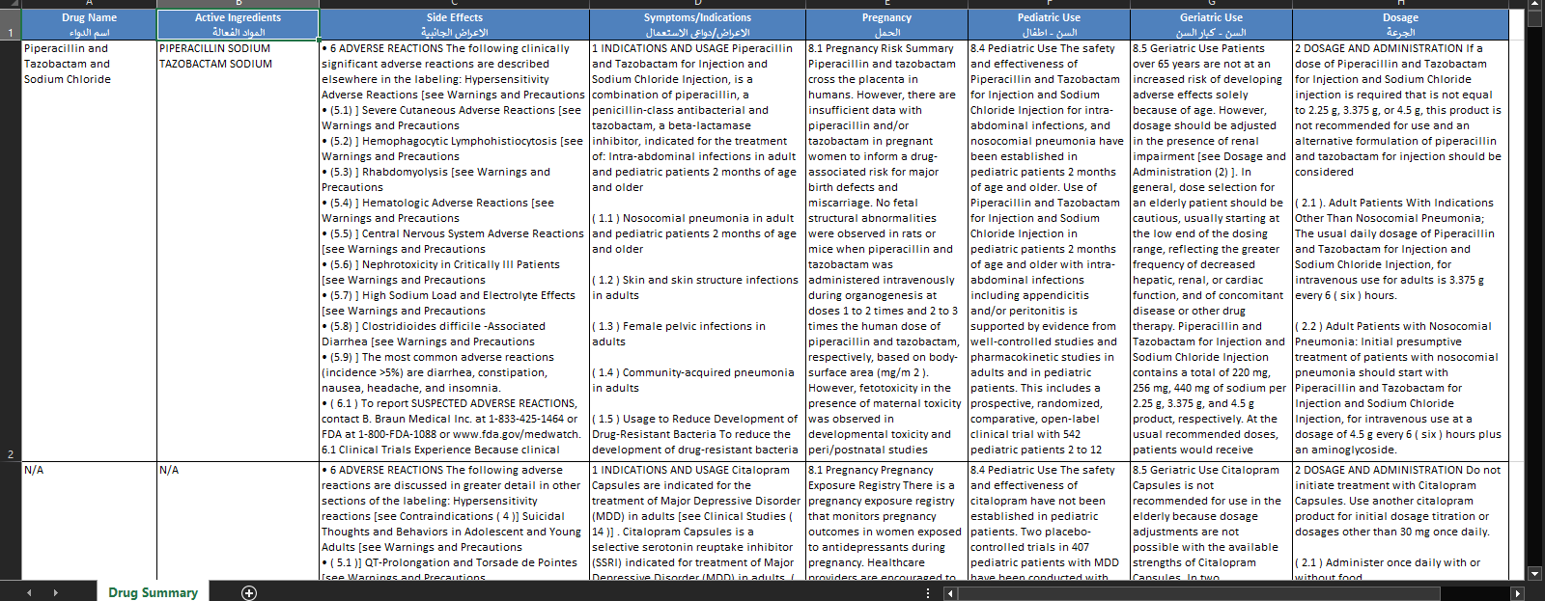

Dataset Description
The dataset used in the MidWise system contains comprehensive pharmaceutical information collected from reliable medical sources. It serves as the primary knowledge base for analyzing medications and identifying potential drug interactions.
Each record in the dataset represents a specific medication and includes several important attributes such as:
- Drug Name: The commercial or generic name of the medication.
- Active Ingredients: The chemical substances responsible for the therapeutic effect of the drug.
- Side Effects: Known adverse reactions and possible risks associated with the medication.
- Symptoms/Indications: Medical conditions and diseases for which the drug is prescribed.
- Pregnancy Information: Safety guidelines and recommendations regarding drug use during pregnancy.
- Pediatric Use: Information about the suitability of the medication for children.
- Geriatric Use: Usage recommendations and precautions for elderly patients.
- Dosage: Recommended dosage instructions and administration guidelines.
The primary purpose of this dataset is to enable the system to compare the active ingredients of multiple medications and determine whether any potential interactions may occur. Additionally, the dataset supports the AI chatbot by providing detailed medication information that can be translated into simple and understandable explanations for users.
By organizing drug-related information into a structured format, the dataset improves the accuracy of interaction detection, enhances medication safety, and supports informed decision-making for patients and caregivers.

